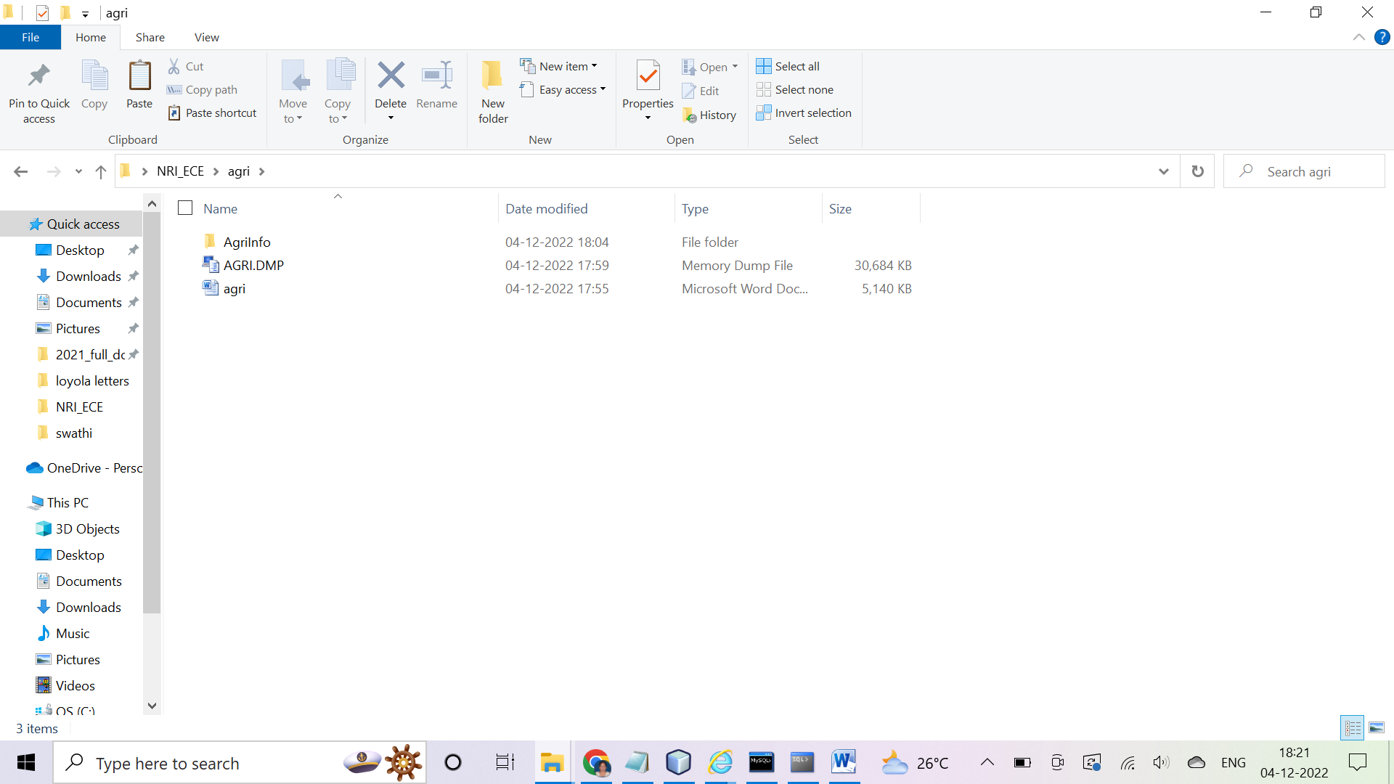

Back end:

User Name: agri

Password : agri

Farmer table creation:

Create table farmer(name varchar2(30),email varchar2(40),phone varchar2(10),addr varchar2(100),pwd varchar2(20));

Stored Procedure to insert a record into database table

Create or replace procedure insert_farmer(name varchar2,email varchar2,phone varchar2,addr varchar2,pwd varchar2) is

Begin

Insert into farmer values(name,email,phone,addr,pwd);

Commit;

End;

/

Function to verify Login :

create or replace function verifylogin(mail varchar2,pw varchar2) return number is

r number;

begin

select count(*) into r from farmer where email=mail and pwd=pw;

if r>0 then

return 1;

else

return 0;

end if;

end;

/

Front end : (java and Jdbc , Jsp Code)

Screen shots :

Home Page :

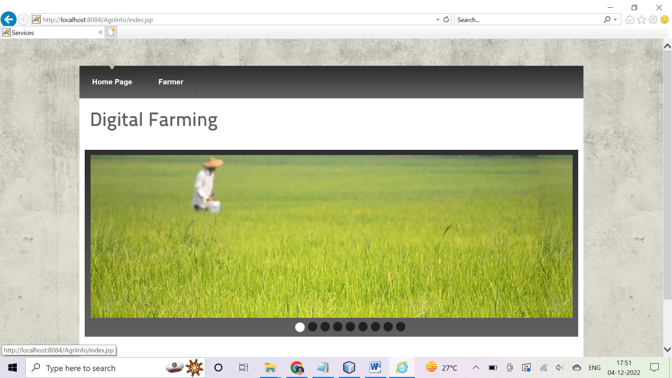

Farmer Signup:

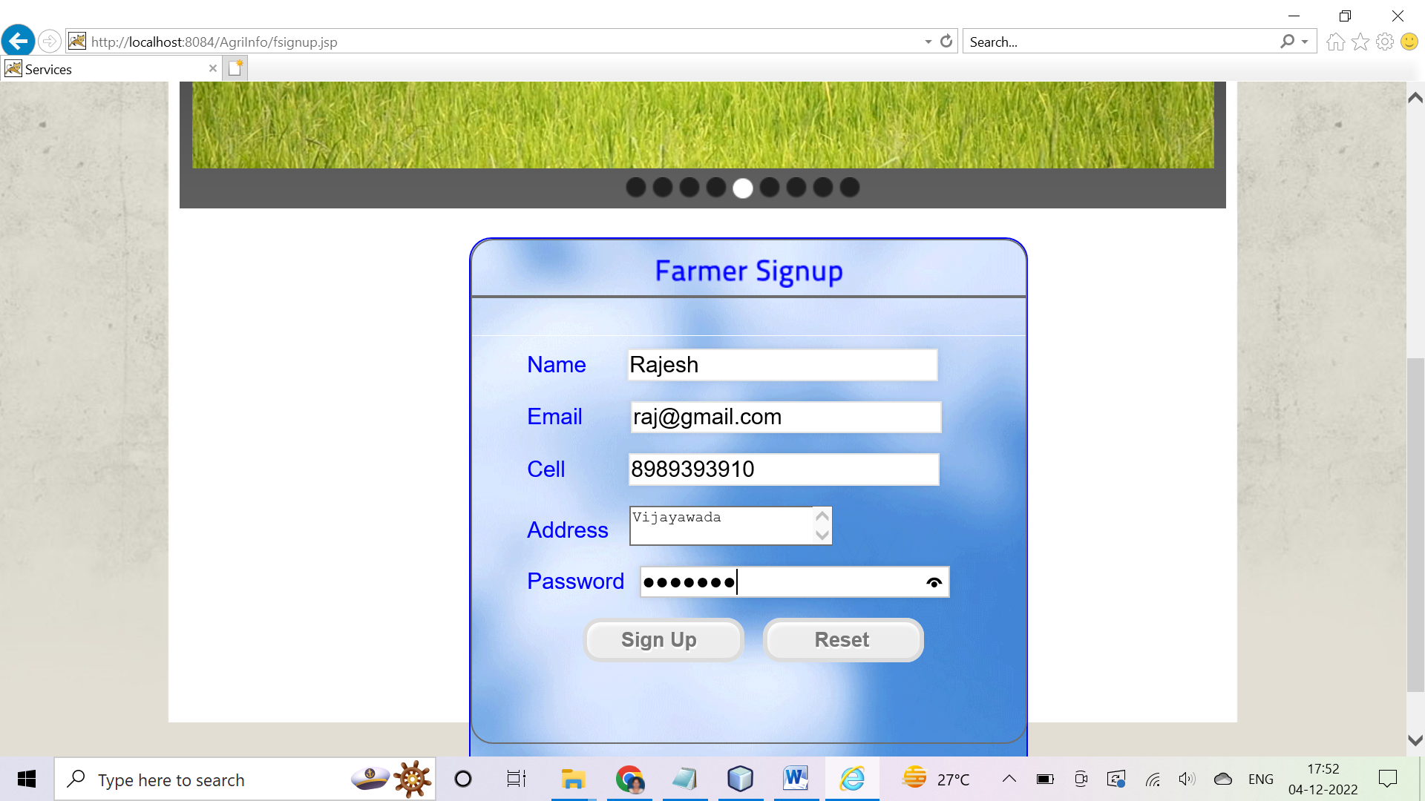

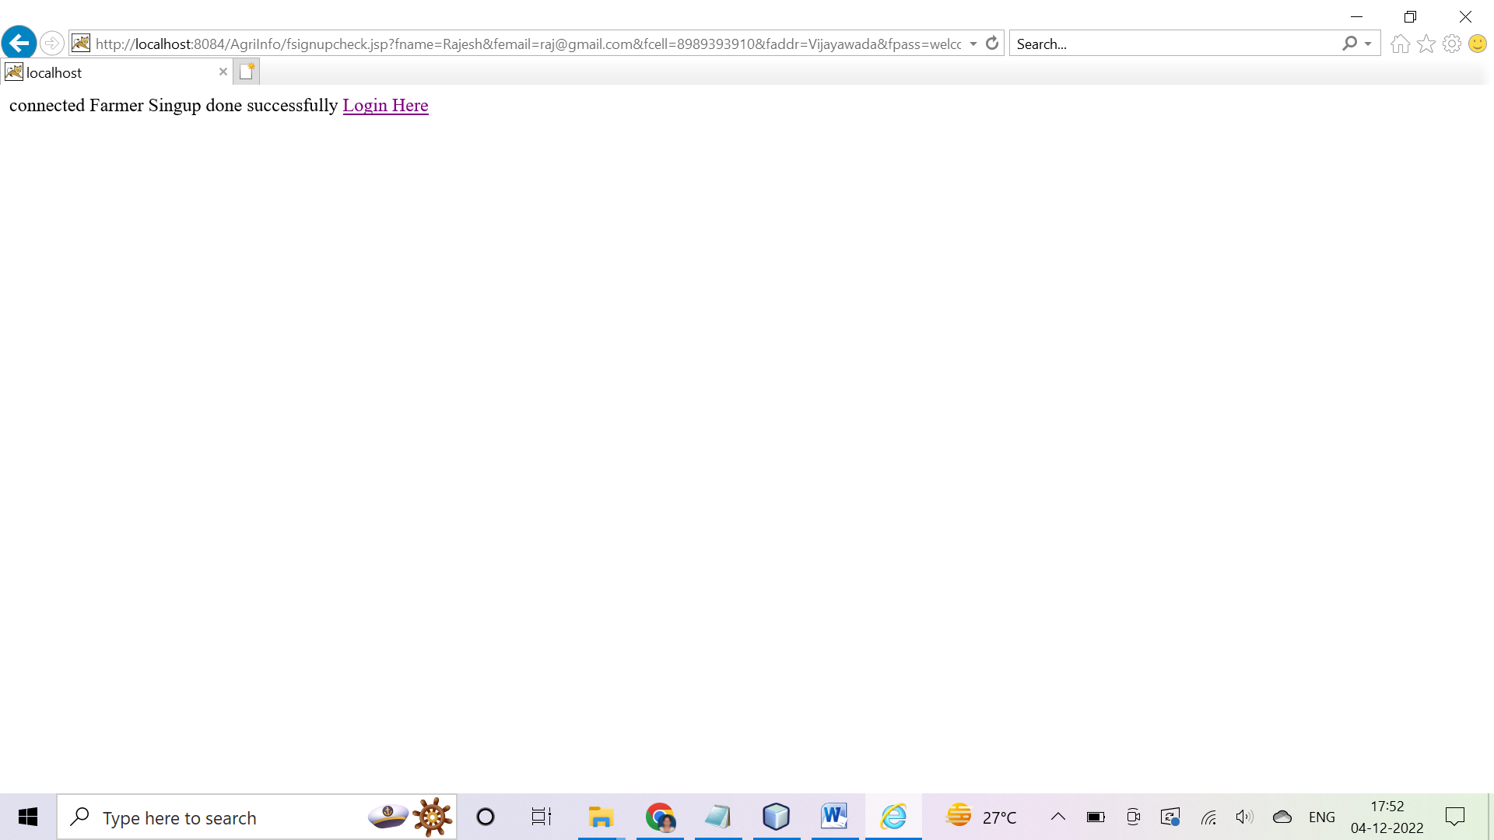

Farmer Login :

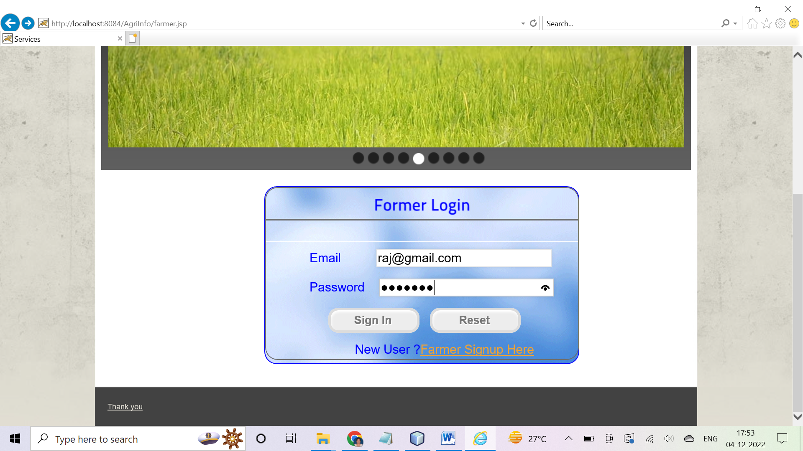

On Success Login :

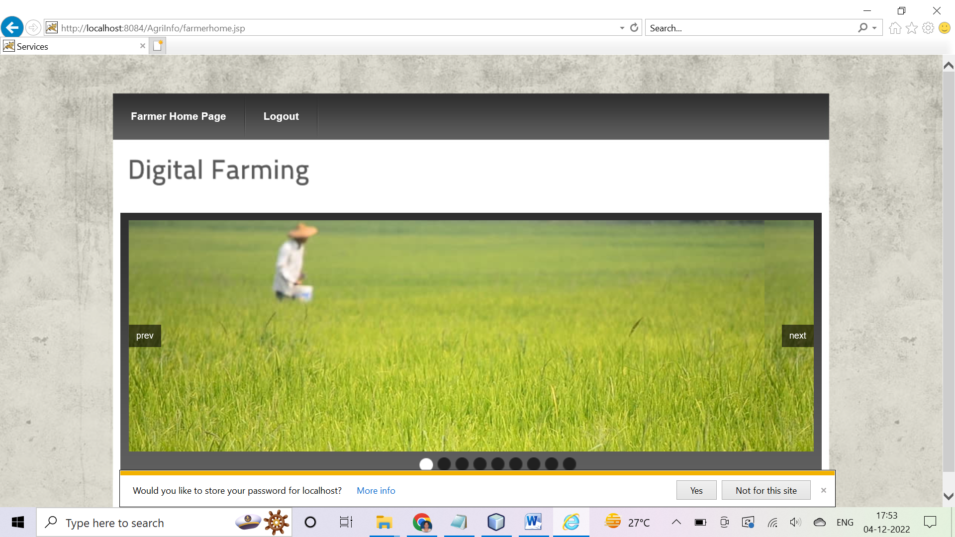

On error Login :

